 | Course Name: Advanced Web Technology | EXPERIMENT NO. 8
 | Course Code: 20CP314P  Faculty: Komal Singh | Branch: CSE
 | Course Code: 20CP314P  Faculty: Komal Singh | Semester: VI
Submitted by: Harsh Shah
Roll no: 21BCP359

Objective: Working with forms in React
- Create a customer review form using react forms for the commercial furniture web-application with multiple fields such as name of the customer(text), the ratings for the customer experience out of 5(a drop-down menu), whether interested in buying again in future (check-box yes or no) and message from the customer(text-area) also ensure that the message should be less than 25 characters.
index.js
import React from "react";
import ReactDOM from "react-dom/client";
import App from "./App.jsx";
import "./index.css";
import { BrowserRouter } from "react-router-dom";

ReactDOM.createRoot(document.getElementById("root")).render(
<React.StrictMode>
<BrowserRouter>
<App />
</BrowserRouter>
</React.StrictMode>
);

App.js
import { Route, Navigate, Routes } from "react-router-dom";
import CustomerReviewForm from "./CustomerReviewForm";
import ThankYouPage from "./ThankyouPage";

function App() {
return (
<div>
<Routes>
<Route path="/" element={<CustomerReviewForm />} />
<Route path="/thankyou" element={<ThankYouPage />} />
<Route path="*" element={<Navigate to="/" />}></Route>
</Routes>
</div>
);
}
export default App;

CustomerReviewForm.jsx
import { useEffect, useState } from "react";
import { useNavigate } from "react-router-dom";

const CustomerReviewForm = () => {
const navigate = useNavigate();
const [submitted, setSubmitted] = useState(false);
const [name, setName] = useState("");
const [rating, setRating] = useState("");
const [interested, setInterested] = useState(false);
const [message, setMessage] = useState("");

const submitForm = (e) => {
e.preventDefault();
setSubmitted(true);
};

useEffect(() => {
if (submitted) {
console.log("Form submitted: ", name, rating, interested, message);
navigate("/thankyou", {
replace: true,
state: { name, rating, interested, message },
});
}
}, [submitted, name, rating, interested, message, navigate]);

return (
<div>
<h1>Commercial Furniture Web Application</h1>
<form onSubmit={(e) => submitForm(e)}>
<table>
<tbody>
<tr>
<td>
<label>Name:</label>
</td>
<td>
<input
type="text"
value={name}
onChange={(e) => setName(e.target.value)}
/>
</td>
</tr>
<tr>
<td>
<label>Rating:</label>
</td>
<td>
<select
value={rating}
onChange={(e) => setRating(e.target.value)}
>
<option value="">Select</option>
<option value="1">1</option>
<option value="2">2</option>
<option value="3">3</option>
<option value="4">4</option>
<option value="5">5</option>
</select>
</td>
</tr>
<tr>
<td>
<label>
Interested in buying again in future:
</label>
</td>
<td>
<label className="checkbox-label">
<input
type="checkbox"
checked={interested}
onChange={(e) =>
setInterested(e.target.checked)
}
/>
Yes
</label>
</td>
</tr>
<tr>
<td>
<label>Message (Max 25 characters):</label>
</td>
<td>
<textarea
value={message}
onChange={(e) => setMessage(e.target.value)}
maxLength={25}
/>
</td>
</tr>
<tr>
<td colSpan="2">
<button type="submit">Submit</button>
</td>
</tr>
</tbody>
</table>
</form>
</div>
);
};
export default CustomerReviewForm;

ThankyouPage.jsx
import { useLocation } from "react-router-dom";

const ThankYouPage = () => {
const location = useLocation();
const formData = location.state;

return (
<div>
<h2>Thank You! for giving feedback</h2>
<p>Name: {formData.name}</p>
<p>Rating: {formData.rating}</p>
<p>
Interested in buying again: {formData.interested ? "Yes" : "No"}
</p>
<p>Message: {formData.message}</p>
</div>
);
};
export default ThankYouPage;

Output
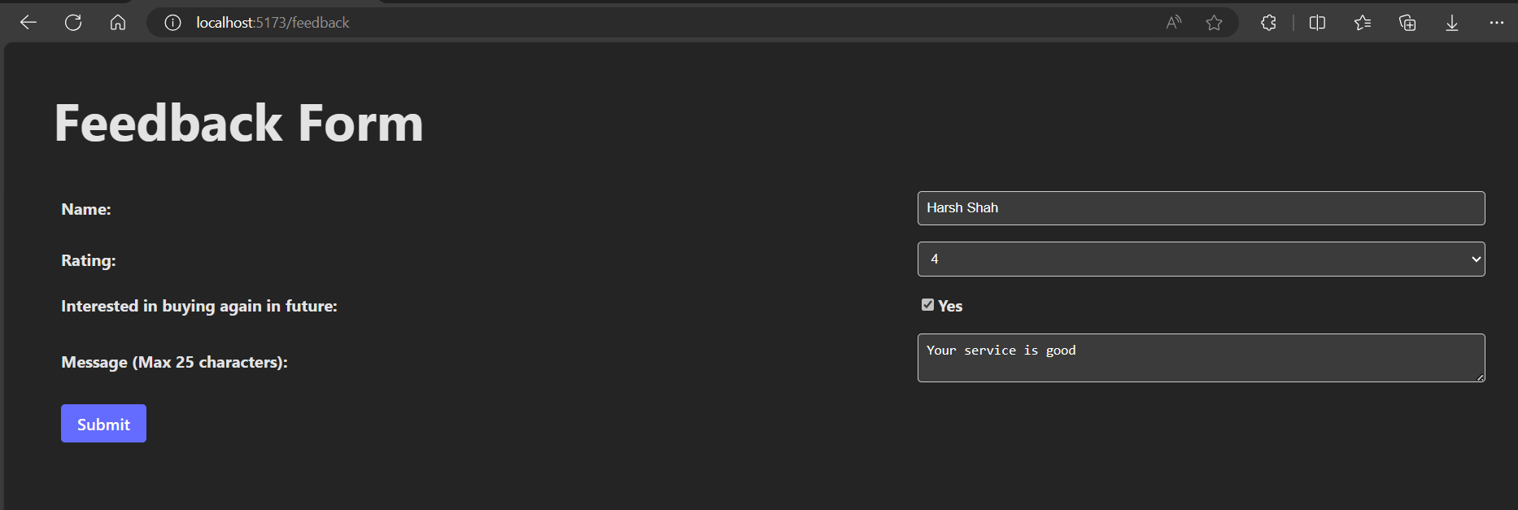
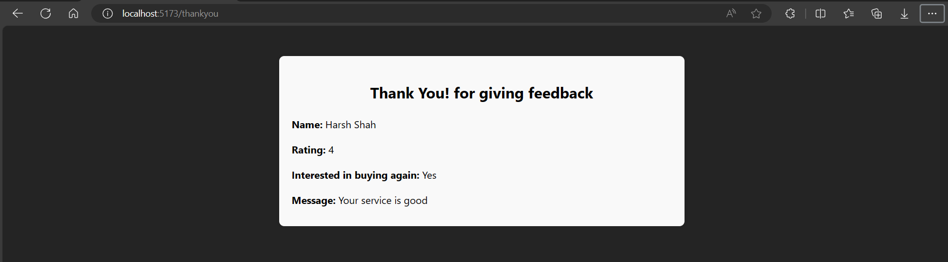

- Create a react form having fields like name (text), division (drop down menu) and message (text-area) using the useRef hook.
StudentData.jsx
import { useRef } from "react";
import { useNavigate } from "react-router-dom";
import "./FormData.css";

const StudentData = () => {
const nameRef = useRef(null);
const divisionRef = useRef(null);
const messageRef = useRef(null);
const navigate = useNavigate();

const handleSubmit = (e) => {
e.preventDefault();

const name = nameRef.current.value;
const division = divisionRef.current.value;
const message = messageRef.current.value;

navigate("/acknowledge", {
state: {
name,
division,
message,
},
});
};

return (
<div>
<h1>Student Details Form</h1>
<form onSubmit={handleSubmit}>
<table className="form-table">
<tbody>
<tr>
<td>
<label htmlFor="name">Name:</label>
</td>
<td>
<input type="text" id="name" ref={nameRef} />
</td>
</tr>
<tr>
<td>
<label htmlFor="division">Division:</label>
</td>
<td>
<select id="division" ref={divisionRef}>
<option value="1">Division 1</option>
<option value="2">Division 2</option>
<option value="3">Division 3</option>
<option value="4">Division 4</option>
<option value="5">Division 5</option>
<option value="6">Division 6</option>
</select>
</td>
</tr>
<tr>
<td>
<label htmlFor="message">Message:</label>
</td>
<td>
<textarea
id="message"
ref={messageRef}
></textarea>
</td>
</tr>
<tr>
<td colSpan="2">
<button type="submit">Submit</button>
</td>
</tr>
</tbody>
</table>
</form>
</div>
);
};

export default StudentData;

Acknowledge.jsx
import { useLocation } from "react-router-dom";
import "./ThankYouPage.css";

const Acknowledge = () => {
const location = useLocation();
const formData = location.state;

return (
<div className="thank-you-container">
<h2 className="thank-you-heading">Thank You for Your Feedback!</h2>
<div className="thank-you-details">
<p>
<strong>Name:</strong> {formData.name}
</p>
<p>
<strong>Division:</strong> {formData.division}
</p>
<p>
<strong>Message:</strong> {formData.message}
</p>
</div>
</div>
);
};
export default Acknowledge;

FormData.css
.form-table {
width: 100%;
border-collapse: collapse;
}

.form-table td {
padding: 8px;
}

.form-table label {
font-weight: bold;
}

.form-table input[type="text"],
.form-table select,
.form-table textarea {
width: 100%;
padding: 8px;
border: 1px solid #ccc;
border-radius: 4px;
box-sizing: border-box;
}

.form-table button {
padding: 8px 16px;
border: none;
border-radius: 4px;
background-color: #646cff;
color: #fff;
cursor: pointer;
}

.form-table button:hover {
background-color: #535bf2;
}

ThankYouPage.css
.thank-you-container {
max-width: 600px;
margin: 0 auto;
padding: 20px;
background-color: #f9f9f9;
border-radius: 8px;
box-shadow: 0 0 10px rgba(0, 0, 0, 0.1);
color: black;
}

.thank-you-heading {
text-align: center;
color: black;
}

.thank-you-details {
margin-top: 20px;
}

.thank-you-details p {
margin-bottom: 10px;
}

.thank-you-details p strong {
font-weight: bold;
}

Output
